

Tournament Directors
Nathan Smith (586)-201-6280
Kyle Stocker (810)-334-8393
Score Reporting: Lyndsey Smith (586)557-0640

Check-in Procedure
- Check in at concession stand there will be a table set up for you to formally check in, where you will turn in your signed tournament waiver sheet and a certificate of your insurance.
Team rules
- Roster: Teams must have a minimum of 9 players no changes or additions can be made to a team's roster after the start of the tournament.
- Each manager is responsible for having copies of their team's birth certificates on hand. In the event of an age challenge, a player will be suspended and not allowed to return until documentation is provided.
- No player can be rostered or appear in a game for more than one team per division.
Good sportsmanship
- Please remember these are youth games. Unsportsmanlike conduct by any coach, player, or spectator will not be tolerated.
- Any verbal abuse of opposing teams, other fans, officials, or tournament staff will result in an automatic ejection. Stay calm and enjoy watching your daughter play.
Ejections
- In the unlikely event you or a member of your team is ejected, please leave the tournament grounds immediately. Failure to do so will result in a forfeit by your team.
- If a player or coach is ejected from a game, they will also be required to miss the next game, even if it's the championship. The ejected player's position in the batting order will be declared an out for the remainder of the game from which they are ejected.
- If an ejected player or coach refuses to leave, the game will be considered a forfeit.
- Coaches are reminded they are responsible for the behavior of their team and fans.
Umpires
- Judgment calls are final and may not be protested. A coach may calmly question a rules violation call to the umpire. You must work out any conflicts with the umpires at the time of the disagreement. All decisions made by the umpire are final. Settle it and move on.
- In the event of a rule dispute, only the head coach may confer with the umpires. No other coach or parent shall address a dispute with an umpire. The umpire may choose to confer with the tournament director or head umpire.
- All umpire decisions are final judgment calls may not be disputed.
- There will be no protests
Unforeseen circumstances
- Unforeseen circumstances could necessitate change to the format of the tournament games impacting the time limit or innings per game.
- Tournament director has discretion to alter format or shorten time limits as necessary to get all games in.
Reporting scores
- Winning team will report scores immediately following the end of the game to Lyndsey Smith (586) 557-0640. Results will be updated on the Marysville Little League app as soon as possible.
Refund policy
- 100% refund if no games are played.
- 50% refund if only one game is played
- 2 games played, no refund.
Home/Away team
- Pool play: Home/Away team determined by coin toss. Coin toss called by team who traveled the farthest.
- Bracket play: Option to be home or away is given to the higher seeded team.
- 1st come, 1st serve pool play and bracket play on dugout selection.
Defensive players
- 8U/9U/10U: Max 10 defensive players. Four players must be outfielders. Outfielders must start in the outfield
- 11U/12U: Max 9 defensive players
Time and inning limits
- 6 innings or 85 minute DROP DEAD time limit on all games. No new inning may start after 75 minutes. NO PLAYER OR COACH MAY INTENTIONALLY SLOW DOWN THE GAME. ANY TEAM FOUND TO INTENTIONALLY SLOW DOWN THE GAME WILL END UP WITH A FORFEIT. Forfeit will be recorded as a 10-0 score.
- If the DROP-DEAD time occurs and the inning has not been completed, the score will revert back to the last completed inning UNLESS THE HOME TEAM HAS TIED OR TAKEN THE LEAD. In the event the home team is batting when the drop-dead time occurs and they have either tied the game or taken the lead then the RESULT STANDS and the score is final. Please watch times- we need the games to move along on schedule.
- A game may end in a tie in pool play. Championship games will not be played under a time limit and cannot end in a tie. Championship round games tied after six innings will be completely played out with international tiebreaker rule.
- Teams should be ready 20 minutes prior to scheduled time in the event of a game ending early or a mercy. Games will begin early if fields are available.
- If a team is not present at regular scheduled game time they will forfeit.

Standing slash tiebreakers- final standings will be determined using the following
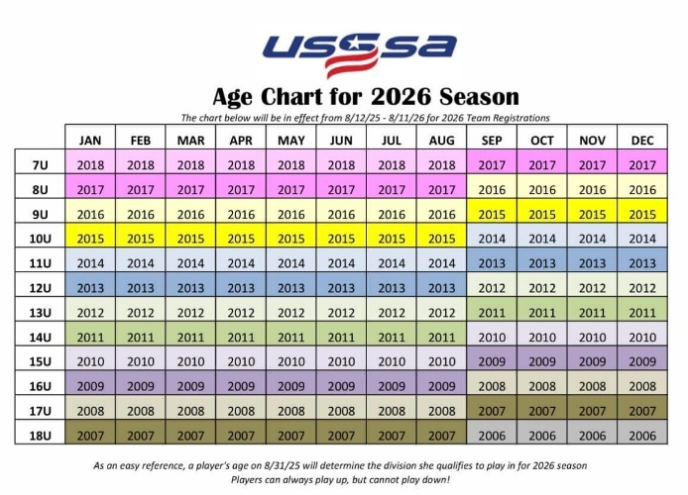
- Overall record
- Head-to-head if all teams have played each other
- Run differential
- Runs allowed
- Runs scored
- Coin flip

Rules
- All rules will follow USSSA unless specified as different.
- Age will be determined by current USSSA age chart.
- No pitch counts
- 9U/10U No dropped third strike rule. Infield fly rule is in effect
- 11U/12U Dropped third strike and infield fly rule are in effect
- 9U/10U/11U/12U Stealing on release of ball from pitchers hand
- Forfeits will be entered as scores of 10-0
International tie breaker rule
- Last batter out of previous inning will start the extra inning on second base. Batter will start with no count and there will be no outs.
Max runs per inning
- 8U/9U/10U 5 runs scored per inning max
- 11U/12U no run limit
Mercy rule
- 15 run lead after 3 innings
- 12 run lead after 4 innings
- 8 run lead after 5 innings
Courtesy runner
- A courtesy runner is allowed for the pitcher or catcher at any time
- In the top of the first inning only the pitcher and catcher are identified as those players listed on the lineup as pitcher and catcher. Thereafter, the pitcher and catcher are identified as the last player who physically played that position on defense
- Courtesy runner must be the player who made the last out; if no outs in the first inning courtesy runner must be last possible player to bat.

Batters/lineups/ rosters
- All games must begin with at least 9 batters regardless of reason for absence.
- Due to injury or ejection, you can finish a game with 8 players. If player is injured and cannot return, no out is recorded when they are due up. If player is ejected, an out is recorded every time they are due up.
- If at any point a team only has 7 players, the game will be recorded as a forfeit regardless of the score of the game.
- No maximum roster size limit but every player must bat. (trophies are only awarded 12 per team)
- Batting order is established with exchange of lineup cards.
- Batting out of order is an appeal play by the defensive team. If error is discovered while the incorrect batter is at bat, the correct batter takes her place and legally assumes any balls and strikes. If error is discovered after the incorrect batter has batted and before the next pitch to the following batter, the player who should have batted is out. Any advance or score made by the improper batter is nullified. If the error is discovered after the first pitch to the next batter, the turn at bat of the incorrect batter is legal and all advancements or runs scored are legal.
Intentional walk
- At any time, a manager may elect to “intentionally walk” a batter by verbally letting the home plate umpire know. It is not necessary to throw 4 pitches
Machine Pitch Rules
- Little League Rules unless specified
- Age to follow USSSA age chart
- The batter has five (5) pitches or 3 strikes (swings) whichever occurs first; may continue to foul off 5th pitch until the ball is in play or strike 3.
- The offensive team’s at-bat is complete after three (3) outs are made or a maximum of 5 runs are scored. There will be no run limit in the 6th inning of bracket games.
- Each team must provide their own person to feed the pitching machine. The person must limit their interaction with the batter, coaching must not delay the at-bat. One (1) warning will be given; sub sequential warnings will result in an automatic out.
- The pitching machine speed will be set at 35 mph, at a distance of 35 feet. The machine may be adjusted only once (1) during an inning upon the agreement of both coaches.
- The entire team roster must bat in a consecutive order throughout the game. Any player absent at the start of the game must be listed as a sub and bat at the end of the line-up if they show up.
- Each team must have at least 8 players to start a game or a forfeit occurs. A forfeit will be recorded as a 10-0 score. A team may play with four outfielders (right field, right/center field, left/center field and left field). No rover is allowed. A maximum of ten (10) players may be on the field at a time. All outfielders must be at least 10 feet from the infield dirt.
- The play is dead once an infielder has possession of the ball on the infield and is not attempting to make a play.
  - If a runner has not reached the hash mark of the base they must return to that base.
  - If they have advanced past the hash mark they will be awarded the next base.
  - This is a judgement call and there will be no protesting or arguing.

- A play may be made on the runner at any base if the play is not dead.
  - A defensive play may be made on any runner and runners may advance at their own risk. Over throw rules still apply. (see rule 14)
- Over Throws: In the event of an overthrow, runners may attempt to advance one (1) base at their own risk. Defense can attempt to make a play on the advancing runner(s); play will be dead after the attempt. There is NO advancement on a 2nd over thrown ball.
- If a batted ball hits the pitching machine and/or operator, the ball becomes dead on contact. All runners including the batter/runner, advance one (1) base only.
- No infield fly rule, no bunting, no stealing and no lead offs.
- The player in the pitcher position must remain even with the pitching machine and one foot must be on or in the circle before/prior to the pitch being pitched.
- Two adult base coaches must be used during your team’s at-bat, plus an adult coach on the bench.
Skills Competition
- Around the horn (4 players per team- throw from home to 1st to 2nd to 3rd to home and back around while timed; fastest team time wins)
- Fasted Feet (1 player per team- run the bases timed)
- 1 Player cannot participate in both events
Errors/omissions
- Tournament host reserves the right to add, delete or alter any rules as needed.
- Tournament host reserves the right to correct any rule errors or omissions as needed.
- In the event a rule is not clearly defined in this packet, USSSA rules will be considered the governing rules.

