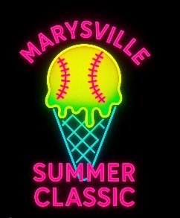
TOURNAMENT WAIVER (must be signed by all participants and guardians) by signing this waiver, I/we, the participant and parent or guardian of the below named, a participant in a Marysville Little League program, hereby agree to give my/our approval to participate in any and all activities. I/we know that participation in any recreational program may result in serious injury/or death and that protective equipment does not prevent all injuries to participants. I/we further acknowledge the risk to have contact with individuals who have been exposed to and/or have been diagnosed with one or more communicable diseases, including but not limited to COVID-19 or other medical conditions or diseases does exist and it is impossible to eliminate the risk that I could be exposed to and/or become infected through contact with or close proximity with an individual with a communicable disease. I knowingly and freely assume all such risks and I do hereby waive, release, absolve, indemnify, and agree to defend and hold harmless Marysville Little League, Marysville public schools, their employees, board of directors, Organizers, volunteers, and any other participants from any claim arising out of any injury or illness to myself or my/our child whether the result of negligence or any other cause. NOTE: all players, parents/ guardians, and coaches/staff MUST SIGN THIS WAIVER. I acknowledge that this form is accurate to the best of my knowledge:

