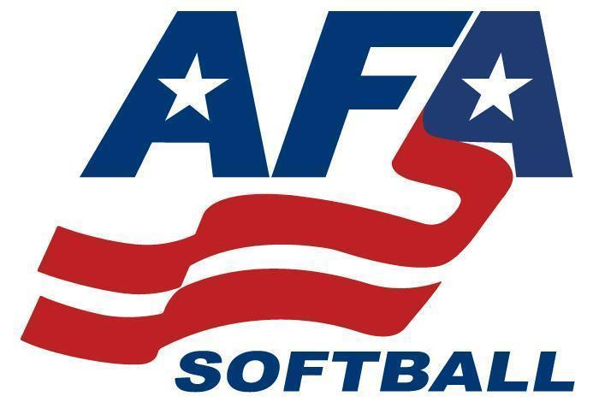

AFA 2025 Nationals Rules

All teams must show their current roster, insurance, and must carry birth certificates

The **American Fastpitch Association** follows the [National Federation of State High School Association](http://www.nfhs.com/) rules with some variations. If you would like to order an NFHS softball rule book you may do so by going to [www.nfhs.com](http://www.nfhs.com/) and selecting the 2020 Softball Rules Book. The American Fastpitch Association does not receive any portion of the cost of purchasing the NFHS rule book. Head coaches are responsible for following all of NFHS rules.

Teams must check in one hour prior to their first game at the AFA site booth.

First base team dugout team listed in pool and top in bracket play.

Coin tosses will determine the home team in pool play games. Higher seeds will get the option of being the home team in an elimination play. Undefeated teams in elimination can have the option of being the home team if facing a one loss team, despite seeding.

**Double Elimination**

All pool games are 1 hour and 30 minutes no new innings

Semifinals and championship games in each Gold Divisions are 7 inning games.

Games may end in a tie during pool play

Elimination games must have a winner

Teams need to be prepared to play up to 20 minutes prior to scheduled start time

Games may be moved to different fields in order to insure games stay on schedule

Teams may use DP/Flex and 2 Extra hitters (EH) for a total of 11 hitters max/12 players

A courtesy runner must come from a sub. That sub can not run for both the pitcher and the catcher. She can only run for one position.

In the event the game goes to international tiebreaker the player who is due to bat last is placed on second base.

Mercy rules: 15 runs after 3 innings, 12 runs after 4 innings, 10 runs after 5 innings, 8 runs after 6 innings

Coaches, please remember to sign up for the app for updates on fields, scores, and other event information.

It is recommended that your team carry a first aid kit and ice packs.

Sportsmanship is a must. Ejected players and coaches may need to sit the following game. Final decision will be made by the UIC. Teams are encouraged to cheer for their players only. It is unsportsmanship to cheer or taunt opposing pitchers.

Absolutely no alcohol, vaping, or smoking at the parks. The cities in Utah will fine violators. Coaches are responsible for their parents and fans.

Fan/Spectator Behavior: A fan/spectator that exhibits unsporting behavior and is removed from a game will at a minimum be required to leave the immediate playing field and exit to the closest parking lot. The situation will be reviewed, and any additional consequences may include the fan/spectator non-admittance for additional games, or the remainder of the tournament.

**PLAYERS MAY ONLY PLAY ON ONE ROSTER DURING THE EVENT**

**Ineligible players will be removed at the time of discovery and suspended for the remainder of the tournament. The head coach will be removed from the game, suspended a minimum of one additional game and UP TO one year at the discretion of AFA..**

**Any coach or player ejected from a game will sit out a minimum of the following game and UP TO one year at AFA discretion.**

Artificial Noise Makers: artificial noise makers are not allowed at any park. While it seems to be a bit strict, noise makers can escalate a potential minor situation into something that is much more severe and unpleasant for all involved. Walk up music must be kept at a low level and turned off when batter steps in the batters box.

Coaches must remain on concrete when their team is playing defense. No coaches on the dirt while their team is on defense. Coaches may be on the field and in the coaches box when on offense.

Please let the previous team clear the dugout before entering.

metal cleats ok for 14u, 16u, 18u

Each location will have a blue AFA canopy. If you have an issue,, please contact the site director at your location.

Download the West Coast AFA tournament ap to follow live scores

<https://itunes.apple.com/us/app/west-coast-afa/id1255908124>

<https://play.google.com/store/apps/details?id=com.exposure.westcoastafa>

Pool Standings Tie Breakers:

W/L Record;

Head to Head play (if two teams tied have each played each other in pool) (if three or more teams have tied we will move to runs allowed)

Run allowed;

Runs scored;

Coin toss

Email: westcoastafa@gmail.com

Website:  [www.westcoastafa.com](http://www.westcoastafa.com/)

Follow us on Instagram [www.instagram.com/westcoastafa/](http://www.instagram.com/westcoastafa/)