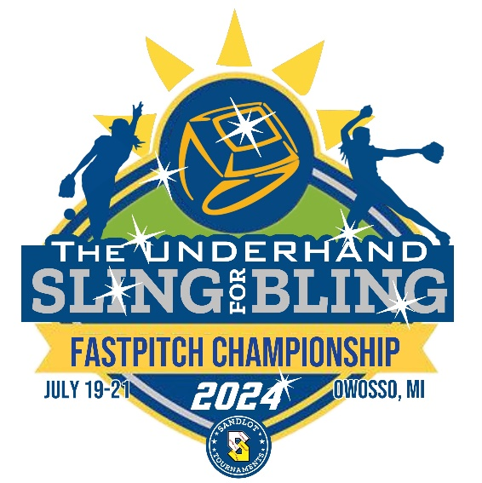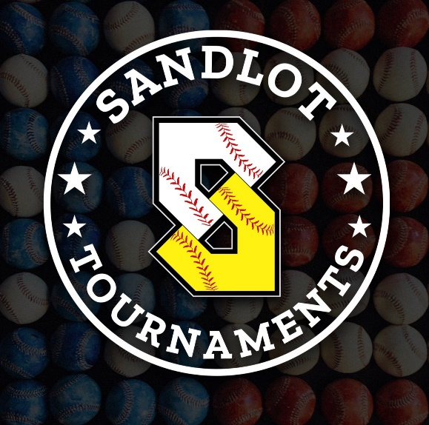

Welcome to the 2024 “Underhand Sling for Bling”, presented by Sandlot Sports Zone!
Sportsmanship
● It is the responsibility of the coaches and/or team managers to control their players, parents and fans.
● Umpires and/or the Tournament Coordinator reserves the right to eject any player, coach or fan from the tournament at any time.
● Poor sportsmanship by a player, coach or fan may result in a game forfeit or team ejection from the tournament, with no refund. Anyone ejected from the tournament will not be allowed back.
Umpires and Appeals
● Umpires’ judgment calls may not be appealed. Interpretation of rules by umpires may be appealed by the head coach only during games by calmly talking to the umpires. There are no appeals of calls or results to the Tournament Director during or after the game.
Registration
● Registration is handled through Exposure Softball. Birth Certificates will be in possession of the coach and all times, and available should the need arise throughout the weekend. Proof of insurance is required to be emailed to sandlotmanagement@gmail.com before the start of your first tournament game.
Player Eligibility
● Teams using ineligible players will forfeit all games and be excused from the tournament, without refund, at the discretion of the Tournament Coordinator.

Tournament Format
● This is a 3 Game Guarantee tournament (2 pool play games and single elimination bracket play). To keep all games moving and on time, games will be as follows....
● Pool and Bracket play games: 10u – 6 innings, 12U/14/16u 7 innings or when the 75-minute time limit has expired. At the 75-minute mark, Drop Dead with revert to last full inning score will be used in POOL PLAY ONLY. NO DROP-DEAD times in bracket play. Run-ahead rules will apply.
● Championship games: No time limit. Mercy rules will apply.
● Ties: Pool play games can end in a tie
● Tie breaker rule for bracket and championship games – International tiebreaker
Seeding Criteria
● Record in pool play
● Head-to-head in pool play
● Least number of runs allowed in pool play
● Number of runs scored
● Coaches best of three Rochambeau (Paper, Rock, Scissors)
Inclement weather policy
● The Tournament Coordinator reserves the right to change the format of the tournament if it is shortened due to inclement weather.
● Pool and Bracket game schedules may be adjusted to complete the tournament. Every attempt to complete the tournament on their scheduled days will be made.
● In the event of a rainout prior to or during the championship game, the higher seeded teams from pool play who have not been eliminated in bracket play, will receive the 1st and 2nd place trophies respectively. Also, 3 complete innings will constitute a complete game for semi-final and championship games if a rainout cancels the remainder of the tournament.
● Team Managers are responsible for staying in contact with tournament staff in the event of inclement weather. All communications will be coming through exposure softball app, so please ensure your coaches, families and friends have access to the site. You need to “follow” your team to ensure communications come to you.
Tournament Field Play Policy
● For our tournament we use fields that are run by the City of Owosso. Sandlot Sports Zone must defer to these parties to determine if the fields can be used in case of bad weather. If they determine the field conditions are non-playable or unsafe the tournament will not continue those fields. Sandlot Sports Zone has no discretion in this matter.
● If your team doesn’t play any games due to weather or other circumstances, a refund minus a $150 administration fee will be given.
● If the first games in your age group of pool play have started and the tournament is cancelled, a $100 refund will be given. If the second games in your age group have started and the tournament is cancelled, no refund will be given.
2024 “Underhand Sling for Bling” Tournament Game Rules
National High School Rules will apply with the following tournament modifications.
1) Official Game Scorebook: Pool play, home and visitor is determined by a best 2 out of 3 Rochambeau (paper, rock scissors) Bracket play, the home team is the higher seeded team. The Home team will keep the official scorebook.
2) Official Line up: (9) players constitute an official line-up. A team may play any portion or all of a game with eight (8) players. An “out” shall be declared each time the “vacated” 9th spot in the order comes up. Exception: An “out” for a vacated ninth position shall not be declared if there are already two outs in an inning and the batter(s) preceding the ninth vacated spot walked.
3) Continuous Batting: For pool play games, continuous batting order is mandatory for all age groups. For bracket play, continuous batting order is mandatory for 12U, and optional for 14U/16U (see below).
4) DH/ or EP (extra player): Optional for 14U/16U bracket play only.
5) Free defensive substitutions: You are not required to report defensive substitutions when batting a continuous lineup. However, you cannot change the batting lineup once it is reported to the umpire.
6) Illness or injury: If a player leaves the continuous batting lineup or base running duties at any point in the game (apart from the courtesy runner rule). That player will not be allowed to return to the game. However, when batting the entire lineup, no out will be charged to a team when a player leaves the batting lineup. The lineup will simply be condensed, and the game will continue. If a player becomes ill/injured while running bases, courtesy runner rules will apply (last out) and the player leaving the game is not allowed to return to the game.
6) Forfeits: A team that does not field at least 8 players within the 10-minute grace period of the scheduled game time will be assessed a forfeit and a loss. A forfeit will be determined as a LOSS with the forfeiting showing no runs scored and 7 runs allowed. The winning team will be credited with a WIN with zero runs allowed and 7 runs scored.
7) Mercy Rule: There will be a “mercy” rule for all pool, bracket and championship games – 12 runs after 3, 10 runs after 4, 8 runs after 5 completed innings.
8) Pitching: Rule 6A, Section 1C: Both feet must be on the ground within the 24-inch length of the pitcher’s mound. The shoulders shall be in line with first and third bases. The pitcher shall take a position with their pivot foot in contact with the pitcher’s mound and their non-pivot foot in contact with or behind the pitcher’s mound. This allows female pitchers to start with one or two feet on the pitcher’s mound. This allows female pitchers to take a backward step from the pitcher’s mound before, during or after the hands are brought together.
9) Pitching Mound distances: 12U-40’, 14U-43’, 16U-43’,
10) Metal cleats: Will be allowed for 14U, 16U
11) Helmets must be worn by all base runners on deck hitters. Bat boys/girls must always wear helmets. Players warming up a pitcher must wear a helmet and mask.

