**The Peffercorn Classic presented by Sandlot Sports Zone**

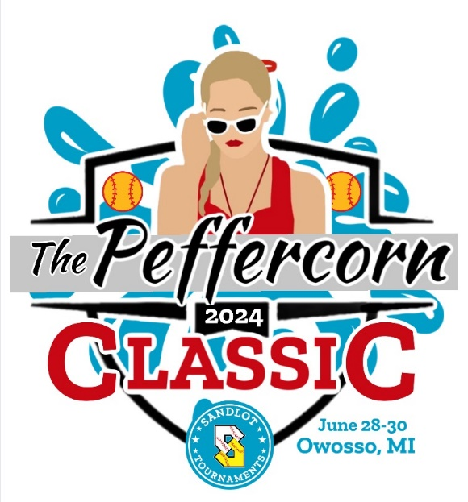

**Coaches, Just a quick note to once again thank you for sharing your weekend with us. We are looking forward to hosting your teams and families, and are hopeful that you will have a great experience that will have you consider us for more tournaments in the future. I wanted to share a few notes about the weekend.**

**Concessions Stand: Owosso Youth Softball will be running a concession stand all weekend long. Every dollar they raise helps to fund the variety of different needs yearly at Bennett Park for the field and youth that use the facility all season long. Their menu has multiple items that almost anyone can find something to eat or drink, and is staffed by an all-volunteer crew.**

**Home Run Derby: We will be running a homerun derby on Saturday. There are individual trophies for each age group, and players can attempt their personal best as many times as they want. It’s $5 a round, and it will be setup on the tee-ball diamond towards the back of the park. At the conclusion of Saturdays’ derby round, winners will be declared. Sunday, trophies will be handed out.**

**Tournament Director: When you get to the fields on Saturday, you will notice one field proudly named after local legend Rick DiBean. Rick has been a part of the Owosso youth softball program for decades, and had dedicated thousands of hours to the care of Bennett Park over the years. This weekend we are blessed to have Rick serve as the tournament director, and primary field care guru. As he has dedicated so much to the fields, please honor him by helping him keep the park clean, safe and fun this weekend. If you get a chance to speak with him, thank him for all that he does out there. We are playing on fields he considers sacred. Please try to have the same reverence for them as he does.**

**Once again, I thank you sincerely for choosing the Peffercorn Classic this weekend. I wish you all the best of luck in the games and in your travel. Highest Regards – Sid Fullwood, Sandlot Sports Zone.**