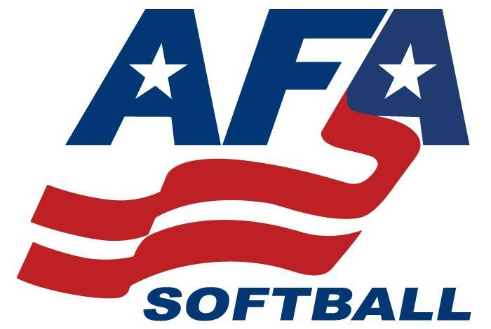

AFA 2023 Nationals Rules

All teams must show their current roster, insurance, and must carry birth certificates

We will follow High School Federation Rules

Teams must check in one hour prior to their first game at the AFA site booth.

First base team dugout team listed in pool and top in bracket play.

Coin tosses will determine the home team in pool play games. Higher seeds will get the option of being the home team in an elimination play. Undefeated teams in elimination can have the option of being the home team if facing a one loss team, despite seeding.

**Double Elimination**

All pool games are 1 hour and 30 minutes no new innings

Semifinals and Championships games in each Gold Divisions are 7 inning games, 6 innings for 8u

Games may end in a tie during pool play

Elimination games must have a winner

Teams need to be prepared to play up to 20 minutes prior to scheduled start time

Games may be moved to different fields in order to insure games stay on schedule

Teams may use DP/Flex and 2 Extra hitters (EH) for a total of 11 hitters max/12 players

Courtesy runners must come from a substitute.

In the event the game goes to international tiebreaker the player who is due to bat last is placed on second base.

Mercy rules: 12 runs after 4 innings, 10 runs after 5 innings, 8 runs after 6 innings

8U home plate is closed and no drop third strikes. Home plate is open on all live balls off the bat, including over throws.

8U no coach pitch.

Coaches, please remember to sign up for the app for updates on fields, scores, and other event information.

Coaches it is recommend that you carry a first aid kit and ice packs.

Sportsmanship is a must. Ejected players and coaches may need to sit the following game. Final decision will be made by the UIC.

Absolutely no alcohol, vaping, or smoking at the parks. The cities in Utah will fine violators.

Please let the previous team clear the dugout before entering.

metal cleats ok for 14u, 16u, 18u

Download the West Coast AFA tournament ap to follow live scores

<https://itunes.apple.com/us/app/west-coast-afa/id1255908124>

<https://play.google.com/store/apps/details?id=com.exposure.westcoastafa>

Pool Standings Tie Breakers:

W/L Record;

Head to Head play (if all teams tied have each played each other)

Run allowed;

Runs scored;

Coin toss

Email: westcoastafa@gmail.com

Website:  [www.westcoastafa.com](http://www.westcoastafa.com/)

Follow us on Instagram [www.instagram.com/westcoastafa/](http://www.instagram.com/westcoastafa/)